CAFETERIA MENU PLANNER
@CREATIVITY THINK (9483175986/7019689991)

ABSTRACT:
Cafeteria Menu Planner is a web-based application designed to simplify meal planning for offices, hostels, schools, and hospitals. The platform enables users to browse food items, plan meals for a day or week, and access nutrition information. Administrators can manage food items, categories, nutrition details, and view dashboard analytics. Built with Django and Django Rest Framework on the backend and React with axios and chart.js on the frontend, the system provides a structured, efficient, and user-friendly solution for meal management and nutritional tracking..

INTRODUCTION OF THE PROJECT:
Managing cafeteria menus and planning meals can be challenging in institutions due to manual record-keeping and lack of structured information. Users often struggle to select balanced meals or track nutrition, while administrators face difficulties in managing food items, categories, and consumption analytics. Cafeteria Menu Planner addresses these issues by offering a centralized platform for menu management, meal planning, and nutrition tracking. The system provides an intuitive interface for both users and admins, enabling organized meal scheduling, informed dietary choices, and analytical insights..

PROJECT OBJECTIVES:

• Create a structured platform for cafeteria menu management
• Allow users to browse food items and categories
• Enable daily and weekly meal planning
• Provide nutrition information for each food item
• Allow administrators to add and manage food items, categories, and nutrition details
• Display dashboard charts and analytics for meal planning trends
• Improve decision-making for balanced meals
• Reduce manual errors in menu planning

PROBLEM OF THE STATEMENT:
Traditional cafeteria meal planning relies on paper records or disconnected spreadsheets, making it difficult to track meals, nutrition, or menu changes. Users lack clear guidance for planning meals, and administrators struggle to manage food items efficiently. Cafeteria Menu Planner solves these problems by centralizing food data, meal planning, and nutrition tracking, offering both users and administrators an automated, transparent, and interactive system..

MOTIVATION OF THE PROJECT:
• To simplify meal planning for individuals and institutions
• To provide nutritional guidance alongside menu information
• To streamline food item and category management for admins
• To reduce errors in manual record-keeping
• To generate dashboards and analytics for informed decision-making
• To enhance user experience through an interactive and responsive interface
• To promote healthy and balanced meal selection

BLOCK DAIGRAM OF PROJECT:

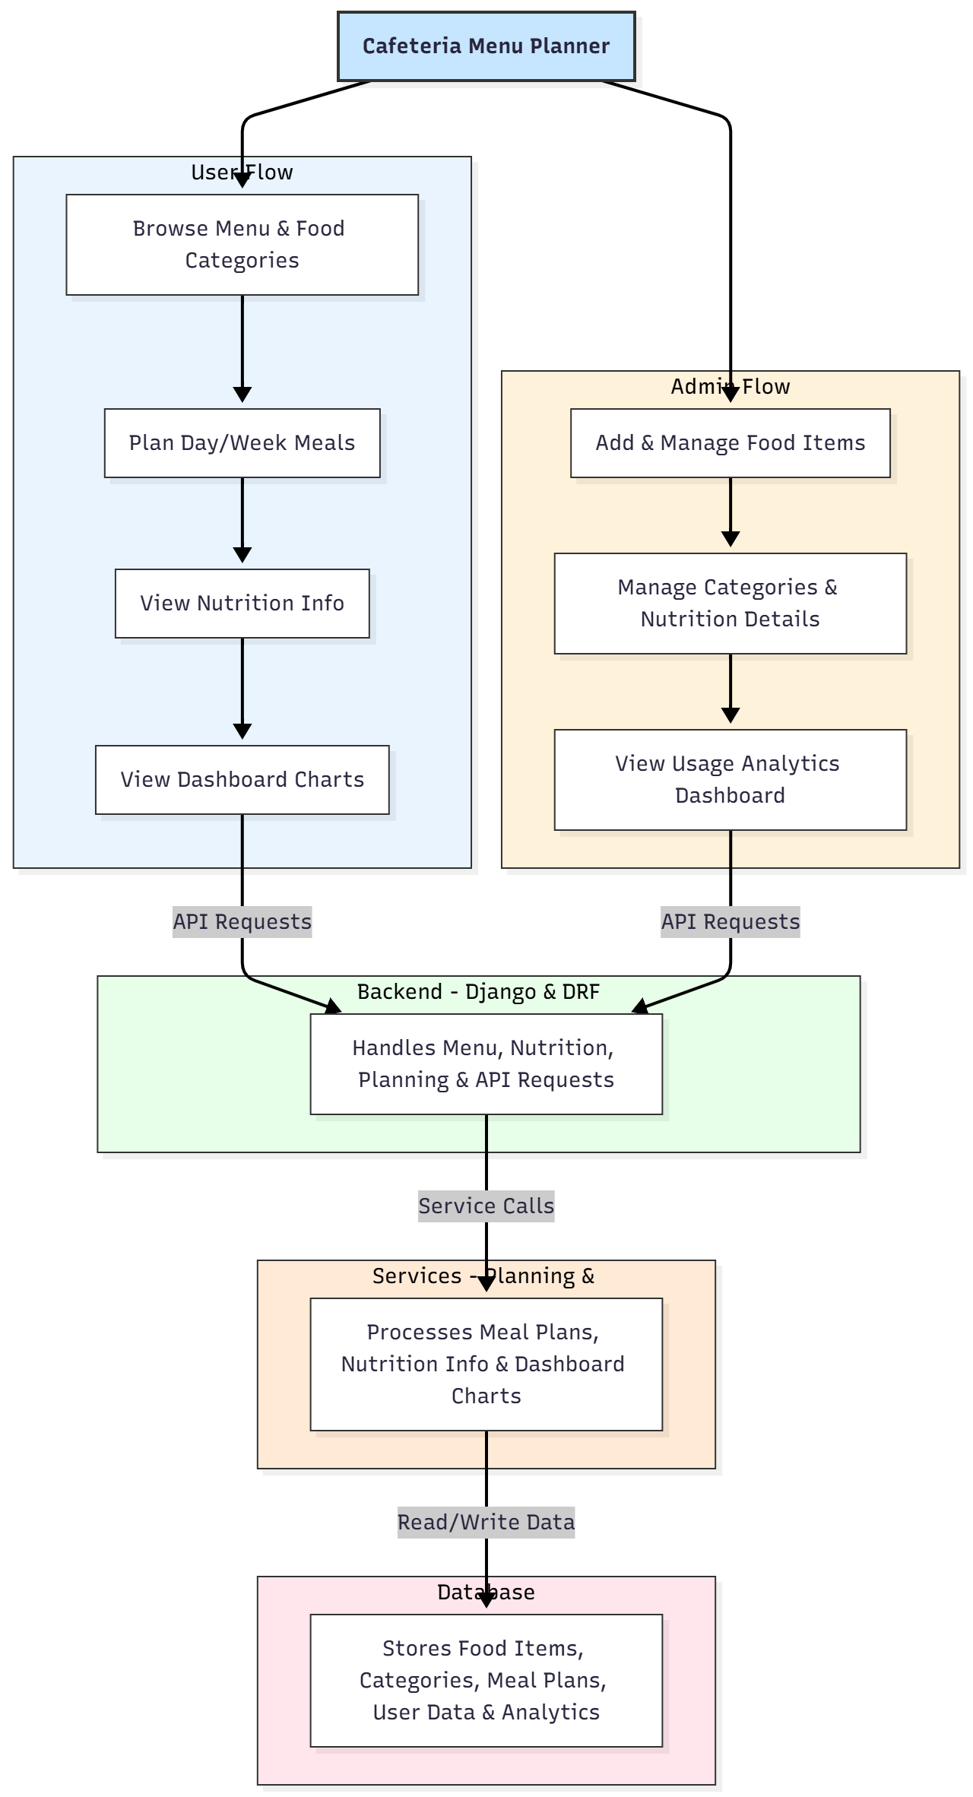

WORKING OF THE PROJECT:
Users begin by browsing the cafeteria menu, selecting food items, and planning meals for a day or week. The backend validates meal plans, ensures availability, and records user selections. Users can view detailed nutrition information for each item and access visual analytics on their planned meals through dashboards. Administrators manage food items, categories, and nutrition details, while the system generates dashboards to monitor user engagement, menu preferences, and consumption trends. The database stores all menu, planning, and analytical data, enabling efficient meal management and reporting..

SOFTWARE REQUIREMENT:
- Backend:
  - Python 3.x
  - Django
  - Django REST Framework
  - SQLite/PostgreSQL
- Frontend:
  - Node.js and npm
  - React.js
  - Axios
- Development Tools:
  - Visual Studio Code
  - Postman (for testing APIs)
  - Git/GitHub (for version control)
- Server/Deployment (Optional):
  - Gunicorn, Nginx, or Heroku/AWS for hosting

ADVANTAGES OF THE PROJECT:

• Simplifies meal planning for individuals and institutions
• Provides nutrition information to support healthy choices
• Dashboard charts for usage trends and analytics
• Centralized management of food items and categories
• Reduces manual record-keeping errors
• Interactive and user-friendly interface
• Improves operational efficiency of cafeterias
• Scalable for schools, offices, hostels, and hospitals

APPLICATIONS OF THE PROJECT:
• Office and corporate cafeterias
• Hostels and dormitories
• School and college canteens
• Hospitals and healthcare facilities
• Catering service planning
• Meal management for research labs

REFERENCES:

- Django REST Framework Documentation — Django Software Foundation. Django Documentation. Available: https://docs.djangoproject.com/
- Django REST Framework. DRF Documentation. Available: https://www.django-rest-framework.org/
- React. React Official Documentation. Available: https://reactjs.org/docs/getting-started.html
- Redux. Redux Documentation. Available: https://redux.js.org/introduction/getting-started
- PostgreSQL Global Development Group. PostgreSQL Documentation. Available: https://www.postgresql.org/docs/
- MySQL. MySQL Reference Manual. Available: https://dev.mysql.com/doc/
- Git. Git Documentation. Available: https://git-scm.com/doc
- Node.js. Node.js Documentation. Available: https://nodejs.org/en/docs/
- Axios. Axios Documentation. Available: https://axios-http.com/docs/intro
- Socket.io Documentation – https://socket.io/docs/

